Exercise 9: GHW#4
Compile group data – Statement of cash flows
Aka: GHW-Compile SCF

Due on ________________
Points possible ________________.

The purpose of this GHW is for teams to aggregate and analyze cash flow data.

This GHW is a companion to Exercise 8, IHW#5 – your firm’s SCF. There are various approaches that groups may want to take to complete this GHW. Some groups may decide that all members of the group should first complete the IHW and then the group meets to aggregate and analyze. Other groups may want to work in tandem to complete the IHW and simultaneously aggregate and analyze the data. Any approach is acceptable, but it is essential that each group member conducts the calculations on his/her own firm and that all members work on the GHW. That is, all group members are fully responsible for their individual firm (IHW) and collectively responsible for the GHW. I may call on individuals to summarize the group’s work and conclusions and each person should be able to answer knowledgeably.

Requirements:

Part 1: For each firm, briefly summarize the firm’s industry.
Part 2: Compare and contrast the different industries. You did this in GHW#2 and GHW#4 but you may want to focus the discussion more on cash flow related items.
Part 3: Compile data from all group members on the template that is available on Blackboard
Part 4a: Produce one graph (or illustration) using data and analysis from your group that shows the most interesting or most perplexing findings.
Part 4b: Provide a short description of what the graph shows and why the group thinks it is of interest.

Part 4 is the most important part of this group assignment.
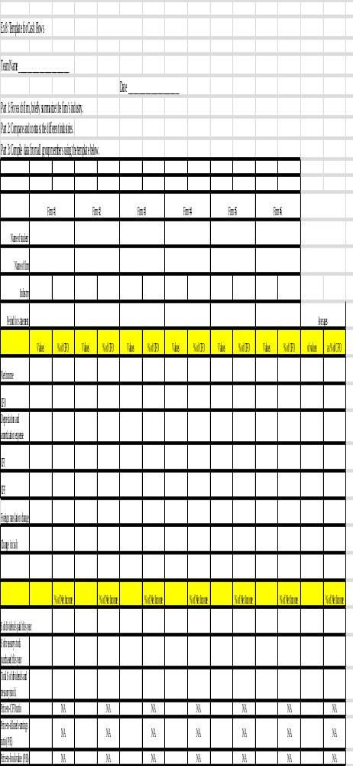

Note that financial statements are not standardized, so you may have to use your best judgment when classifying your firm's accounts into the template.

